**Chapter 2**

**Vectors in Space**

**2.2 Vectors in Three Dimensions**

**Section Exercises**

61. Consider a rectangular box with one of the vertices at the origin, as shown in the following figure. If point is the opposite vertex to the origin, then find

1. the coordinates of the other six vertices of the box and
2. the length of the diagonal of the box determined by the vertices  and.

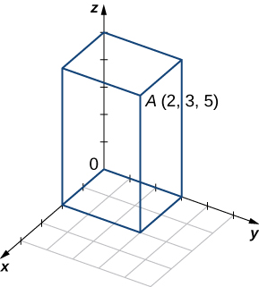

Answer: a.  b. 

62. Find the coordinates of point  and determine its distance to the origin.

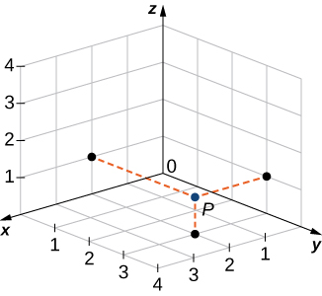

Answer:  

**For the following exercises, describe and graph the set of points that satisfies the given equation.**

63. 

Answer: A union of two planes:  (a plane parallel to the  plane) and  (a plane parallel to the plane)

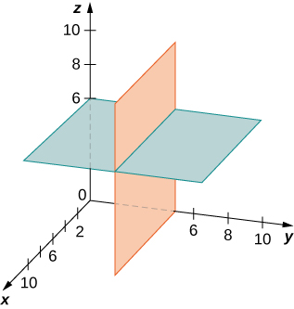

64. 

Answer: A union of two planes:  and  that are each parallel to the plane

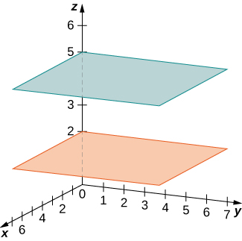

65. 

Answer: A cylinder of radius  centered on the line 

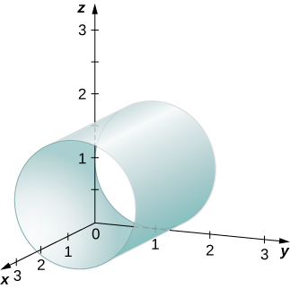

66. 

Answer: A cylinder of radius  centered on the line 

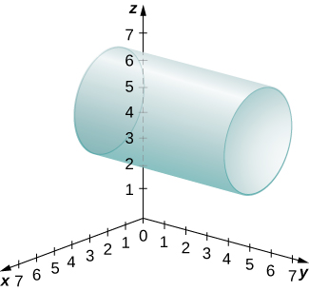

67. Write the equation of the plane passing through point  that is parallel to the plane.

Answer: 

68. Write the equation of the plane passing through point  that is parallel to the plane.

Answer: 

69. Find an equation of the plane passing through points   and 

Answer: 

70. Find an equation of the plane passing through points   and 

Answer:

**For the following exercises, find the equation of the sphere in standard form that satisfies the given conditions.**

71. Center  and radius 

Answer: 

72. Center  and radius 

Answer: 

73. Diameter  where  and 

Answer: 

74. Diameter  where  and 

Answer: 

**For the following exercises, find the center and radius of the sphere with an equation in general form that is given.**

75.  

Answer: Center  and radius 

76. 

Answer: Center  and radius 

**For the following exercises, express vector  with the initial point at  and the terminal point at **

1. **in component form and**
2. **by using standard unit vectors.**

77.  and 

Answer: a.  b. 

78.  and 

Answer: a.  b. 

79.  and  where  is the midpoint of the line segment 

Answer: a.  b. 

80.  and  where  is the midpoint of the line segment 

Answer: a.  b. 

81. Find terminal point  of vector  with the initial point at 

Answer: 

82. Find initial point  of vector  with the terminal point at 

Answer: 

**For the following exercises, use the given vectors  and  to find and express the vectors   and  in component form.**

83.  

Answer:   

84.  

Answer:   

85.  

Answer:  

86.  

Answer:   

**For the following exercises, vectors u and v are given. Find the magnitudes of vectors  and **

87.  

Answer:  

88.  ..

Answer:  

89.   where  is a real number.

Answer:  

90.   where  is a real number.

Answer:  

**For the following exercises, find the unit vector in the direction of the given vector  and express it using standard unit vectors.**

91. 

Answer: 

92. 

Answer: 

93.  where  and 

Answer: 

94.  where 

Answer: 

95.  where   and 

Answer: 

96.  where   and 

Answer: 

97. Determine whether  and  are equivalent vectors, where  and 

Answer: Equivalent vectors

98. Determine whether the vectors  and  are equivalent, where    and 

Answer: Not equivalent vectors

**For the following exercises, find vector  with a magnitude that is given and satisfies the given conditions.**

99.    and  have the same direction

Answer: 

100.    and  have the same direction

Answer: 

101.    and  have opposite directions for any  where  is a real number

Answer: 

102.    and  have opposite directions for any  where  is a real number

Answer: 

103. Determine a vector of magnitude  in the direction of vector  where  and 

Answer: 

104. Find a vector of magnitude  that points in the opposite direction than vector  where  and  Express the answer in component form.

Answer: 

105. Consider the points  and  where  and are negative real numbers. Find  and  such that 

Answer:  

106. Consider points and  where and  are positive real numbers. Find  and  such that 

Answer: 

107. Let  be a point situated at an equal distance from points  and Show that point  lies on the plane of equation 

Answer: This is a proof; therefore, no answer is provided.

108. Let  be a point situated at an equal distance from the origin and point  Show that the coordinates of point  satisfy the equation 

Answer: This is a proof; therefore, no answer is provided.

109. The points  and  are collinear (in this order) if the relation  is satisfied. Show that   and  are collinear points.

Answer: This is a proof; therefore, no answer is provided.

110. Show that points   and  are not collinear.

Answer: This is a proof; therefore, no answer is provided.

111. **[T]** A force  of  acts on a particle in the direction of the vector  where 

1. Express the force as a vector in component form.
2. Find the angle between force  and the positive direction of the axis. Express the answer in degrees rounded to the nearest integer.

Answer: a.  b. 

112. **[T]** A force  of  acts on a box in the direction of the vector  where 

1. Express the force as a vector by using standard unit vectors.
2. Find the angle between force  and the positive direction of the axis.

Answer: a.  b. 

113. If  is a force that moves an object from point  to another point  then the displacement vector is defined as  A metal container is lifted  m vertically by a constant force  Express the displacement vector  by using standard unit vectors.

Answer: 

114. A box is pulled  yd horizontally in the direction by a constant force  Find the displacement vector in component form.

Answer: 

115. The sum of the forces acting on an object is called the *resultant* or *net force*. An object is said to be in static equilibrium if the resultant force of the forces that act on it is zero. Let   and  be three forces acting on a box. Find the force  acting on the box such that the box is in static equilibrium. Express the answer in component form.

Answer: 

116. **[T]** Let   be  forces acting on a particle, with 

1. Find the net force  Express the answer using standard unit vectors.
2. Use a computer algebra system (CAS) to find *n* such that 

Answer: a.  b. 

117. The force of gravity  acting on an object is given by  where *m* is the mass of the object (expressed in kilograms) and  is acceleration resulting from gravity, with  A 2-kg disco ball hangs by a chain from the ceiling of a room.

1. Find the force of gravity  acting on the disco ball and find its magnitude.
2. Find the force of tension  in the chain and its magnitude.

Express the answers using standard unit vectors.



Answer: a.   N; b.  N

118. A -kg pendant chandelier is designed such that the alabaster bowl is held by four chains of equal length, as shown in the following figure.

1. Find the magnitude of the force of gravity acting on the chandelier.
2. Find the magnitudes of the forces of tension for each of the four chains (assume chains are essentially vertical).

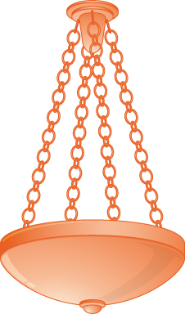

Answer: a.  N; b.  N,  N,  N,  N

119. **[T]** A 30-kg block of cement is suspended by three cables of equal length that are anchored at points  .. and  The load is located at  as shown in the following figure. Let  and  be the forces of tension resulting from the load in cables and  respectively.

1. Find the gravitational force  acting on the block of cement that counterbalances the sum  of the forces of tension in the cables.
2. Find forces   and  Express the answer in component form.

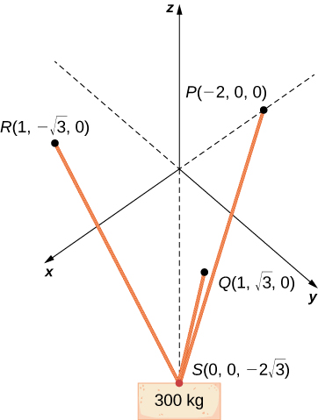

Answer: a.  N; b.   and  (each component is expressed in newtons)

120. Two soccer players are practicing for an upcoming game. One of them runs 10 m from point *A* to point *B*. She then turns left at  and runs 10 m until she reaches point *C*. Then she kicks the ball with a speed of 10 m/sec at an upward angle of  to her teammate, who is located at point *A*. Write the velocity of the ball in component form.

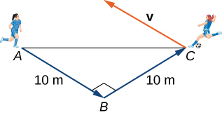

Answer: 

121. Let  be the position vector of a particle at the time  where  and  are smooth functions on  The instantaneous velocity of the particle at time  is defined by vector  with components that are the derivatives with respect to  of the functions *x*, *y*, and *z*, respectively. The magnitude  of the instantaneous velocity vector is called the *speed of the particle at time* t. Vector  with components that are the second derivatives with respect to  of the functions  and  respectively, gives the acceleration of the particle at time Consider  the position vector of a particle at time  where the components of  are expressed in centimeters and time is expressed in seconds.

1. Find the instantaneous velocity, speed, and acceleration of the particle after the first second. Round your answer to two decimal places.
2. Use a CAS to visualize the path of the particle—that is, the set of all points of coordinates  where 

Answer: a.  (each component is expressed in centimeters per second); (expressed in centimeters per second);  (each component expressed in centimeters per second squared);

b.

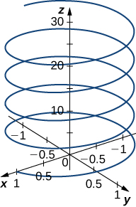

122. **[T]** Let  be the position vector of a particle at time  (in seconds), where (here the components of  are expressed in centimeters).

1. Find the instantaneous velocity, speed, and acceleration of the particle after the first two seconds. Round your answer to two decimal places.
2. Use a CAS to visualize the path of the particle defined by the points  where 

Answer: a.  (each component is expressed in centimeters per second),  (expressed in centimeters per second),  (each component is expressed in centimeters per second squared);

b.

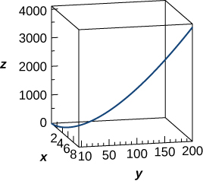

This file is copyright 2016, Rice University. All Rights Reserved.